
Embedded Systems 22442
Final Report

Student Names:
Kareem Refai 20220422 – IoT Engineering
Sanad Sweidan 20220744 – Electrical Power and Energy Engineering
Talal Awadi 20221147 – Computer Engineering

Supervisors:
Doctor Belal Sababheh
Eng. Majd Alfedailat

Table of Contents
Abstract 3
Introduction 3
Mechanical Design 4
Electrical Design 4
Motor Configuration 5
H-Bridge 5
Power Supply 5
Voltage Regulation 5
Pin Mapping 6
Software 6
Start Zone 6
Line – Following Zone 6
The Tunnel Zone 7
Maze Navigation Zone 7
Finish Zone 7
Problems and Recommendations 9
Conclusion 9

Abstract
This project presents the design, development, and implementation of a two-wheeled robotic vehicle using the PIC16F877A microcontroller. The vehicle is capable of line-following using infrared (IR) sensors, detecting ambient light using a Light Dependent Resistor (LDR), and navigating a simple maze using 3 obstacle detection IR sensors. Pulse Width Modulation (PWM) is employed to control motor speeds, while a servo motor is used to show the end of the track. The project demonstrates an efficient, and programmable robotic platform suitable for educational purposes and basic robotics research.

Introduction
Autonomous mobile robots are a key focus in the study of embedded systems and robotics because they bring together mechanical design, electronics, and control theory into a single, working device. In this project, we designed and built such a robot to take part in the Autonomous Mobile Robots Challenge, an event closely aligned with the goals of the Embedded Systems curriculum. The competition tests the robot’s ability to navigate independently through a multi-zone course, requiring it to complete each stage accurately and efficiently.

The course itself is divided into several distinct sections, including a line-following track, a dark tunnel, a maze, and a final parking area. Each zone presents its own unique challenges, simulating real-world conditions that push the robot’s navigation and decision-making systems to perform reliably under varying and unpredictable circumstances.

Mechanical Design

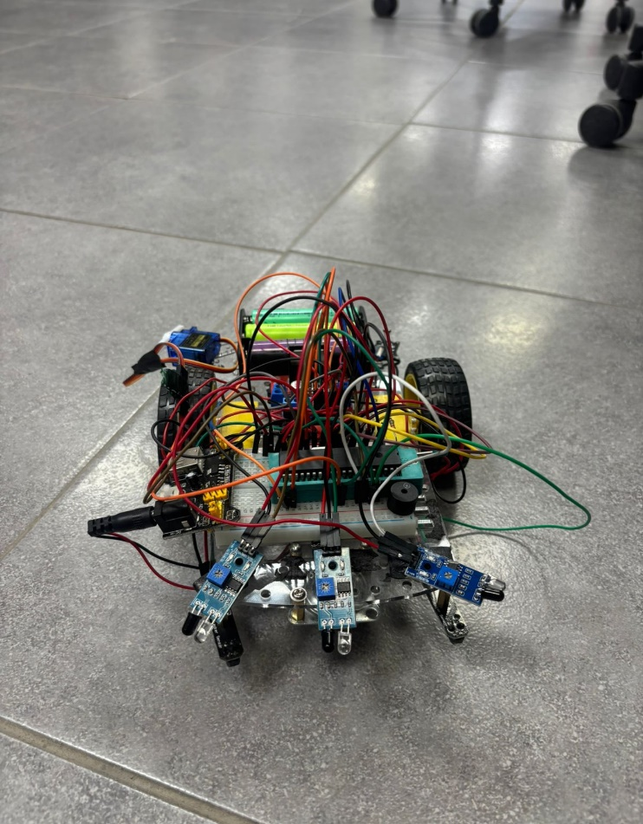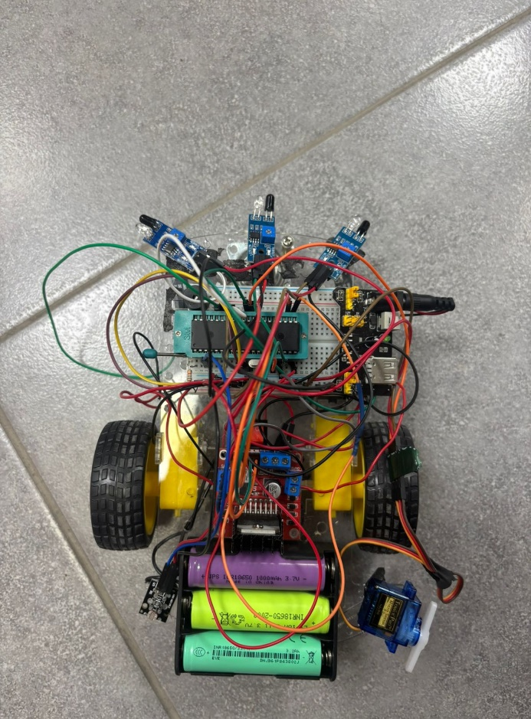

The robot is built on a two-wheel differential drive (2WD) chassis with two DC motors directly attached to the wheels, providing efficient propulsion and precise control. This design allows the robot to turn and maneuver accurately by adjusting the speed of each motor independently.

Electrical Design
The electrical design focuses on motor control, power, and system safety.

Motor Configuration
The robot uses a two-wheel differential drive system, where each wheel is powered independently by its own DC motor. The motors are controlled using Pulse Width Modulation (PWM) through the PIC16F877A microcontroller, which allows fine adjustment of wheel speeds for smooth and accurate navigation. Each motor pair is electrically connected in parallel, providing two different motor outputs: An output for the left motor, and an output for the right motor.

H-Bridge
An H-bridge motor driver is used to control the speed and direction of motors. Both motor connections are directly linked to the H-bridge motor driver output terminals.

Power Supply
The vehicle is powered by a battery, which gives energy for the motors and the control system of the robot.

Voltage Regulation
A voltage regulator is used in order to stabilize the voltage supply to the control circuit. The ground terminal of the voltage regulator is connected to the common ground of the H-Bridge. The positive terminal of the voltage regulator is connected to the positive output terminal of the power switch. That ensures the motors and the regulated logic share a common ground at appropriate voltage levels for components like the microcontroller and the sensors connected.

Pin Mapping

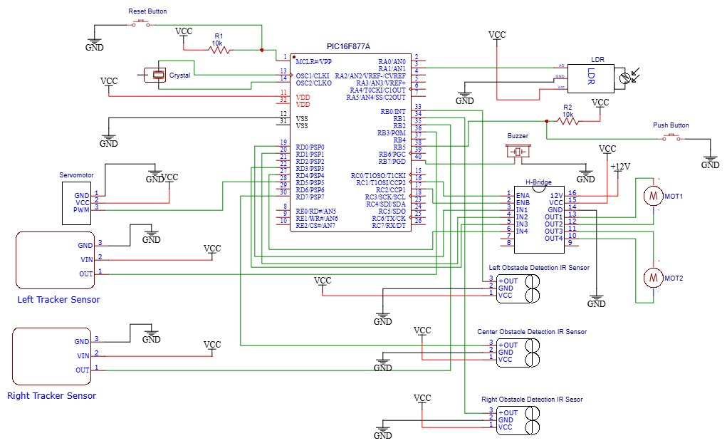

Software

Start Zone
The car begins in the start zone, waiting for the power switch to be pressed. The car transitions from the idle state to the active driving state and begins moving forward toward the line-following zone.

Line – Following Zone
The car must follow the black line on the floor. The track includes one straight section, one T-shaped intersection, and one curved line. The car moves at a stable speed along the straight path and smoothly handle the curve and the intersection.

The Tunnel Zone
The black line leads into a tunnel with reduced lighting. When the car enters the tunnel, it must detect the drop in light intensity using the analog value from an LDR sensor. Upon detection, the car must activate a buzzer to signal entry into the dark zone, and it must remain activated until it leaves the zone.

Maze Navigation Zone
the robot enters a maze-like section without any guiding lines. The maze is composed of corridors with varying fixed widths; some sections are approximately 40 cm wide, while others are 50 cm wide, with walls consistently 30 cm high. The robot must autonomously navigate through the maze to reach the designated stop position.

Finish Zone
After passing through the maze, the car enters the 50x50 cm finish zone. This zone will have a black floor color. Upon detecting this area, the car should stop completely and raise a flag to indicate successful completion of the challenge.

A flowchart has been made to show how our vehicle navigates through the entire track.

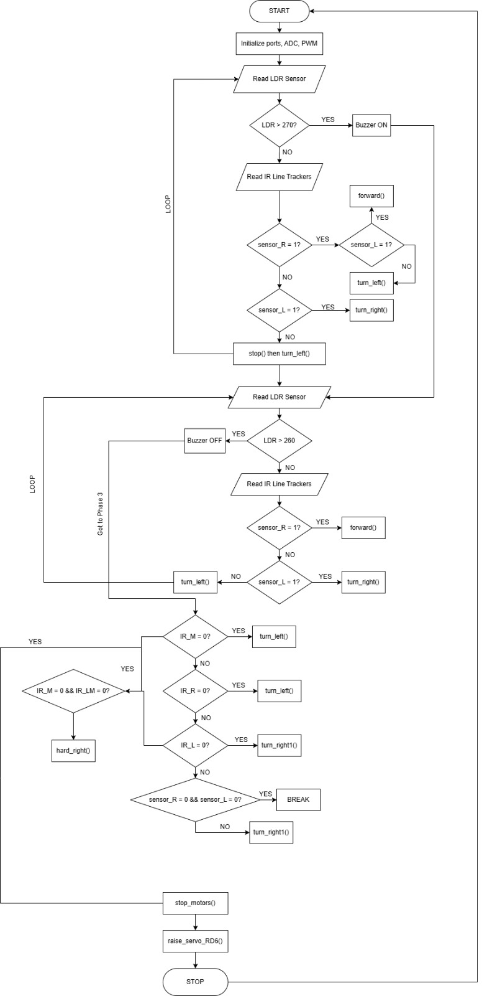

Problems and Recommendations
There have been a couple problems that we faced, for example:
- After the vehicle exits the tunnel, the car drifts to the left, noticing the left obstacle detection sensor, but it still hits the wall.
- The PIC16F877A kept getting stuck to the breadboard and we couldn’t remove it easily.
- Before using obstacle detection IR sensors, we tried to use an ultrasonic sensor and a sharp IR sensor, but they did not notice the walls at all.
- The vehicle kept shutting off completely, even with the batteries being fully charged.
- The right motor was not working for a period of time, noticing it was not welded good enough.
Following these problems, we have improvised as a team to come up with solutions.
- After thoroughly looking at the code, to fix the issue of the car drifting after exiting the tunnel, we decreased the threshold of the LDR after the buzzer was on, and decreased the speed of the right motor so that it continues to move forward instead of the vehicle continues to drift to the left.
- We used a ZIF socket to help us input and remove the PIC easily and safely.
- We removed the ultrasonic and the sharp IR, and added 3 obstacle detection IRs instead. It helped us configure the code easily and helped the vehicle go through the track better.
- We fixed the wiring situation as we noticed that some of the sensors’ jumper wires kept bumping into the VSS and VDD’s jumper wires.
- We welded everything back together safely and carefully, using all safety precautions.

Conclusion
In conclusion, the development of the vehicle integrates mechanical, electrical and embedded programing into a single autonomous system. Through careful implementation of the entire track, the robot successfully navigates the designated track and responds to environmental cues. The robot’s behavior is governed by a state-based embedded software architecture that processes sensor inputs and timing events to control navigation decisions across all track zones. This project provides relevant experience in robotics and problem-solving.

